**Cheating Detection System during Online Examination**

**Submitted in partial fulfillment of the requirements for the award of the degree of**

**Bachelors in Computer Application**



**Team Members (Submitted by):-**

Name:- Soumya Deep Saha (Roll no:- 31101221028)

Name:-Ishita Sen (Roll no:- 31101221011)

Name:-Shreshta Saha (Roll no:- 31101221044)

Name:-Sutanu Mukherjee(Roll no:- 31101221001)



May 2024

Submitted to

**Dr.Ananjan Maity**, **Mr. Chiranjib Dutta (HOD)**

Project Coordinators (BCA)

Department of Computer Application.

-----------------------------------------------------------------------------------------

Guru Nanak Institute of Technology.

157/F Nilgunj Road. Kolkata – 700 114 West Bengal

**DECLARATION**

This is to certify that the major project entitled

“**Cheating Detection During Online Examination System**” Submitted towards the partial fulfillment of BCA 6th Semester, Department of Computer Application of Guru Nanak Institute of Technology (GNIT).

Was carried out by **Mr. Soumya Deep Saha (Roll no - 31101221028**), **Ms. Ishita Sen (Roll no - 31101221011)**, **Ms. Shreshta Saha (Roll no - 31101221044)**, **Mr. Sutanu Mukherjee (Roll no - 31101221001).**

Under the supervision of **Prof. Dr. Ananjan Maity, Asst. Prof. Dept of Computer Application, Guru Nanak Institute of Technology**. The matter embodied in this project work is genuine and motivating for future works.

------------------------- ------------------------

Soumya Deep Saha (Leader) Shreshta Saha

------------------------- ------------------------

Ishita Sen Sutanu Mukherjee

**Certificate**

This is to certify that the major project entitled

“**Cheating Detection During Online Examination System**” Submitted towards the partial fulfillment of BCA 6th Semester, Department of Computer Application of Guru Nanak Institute of Technology (GNIT).

Was carried out by team leader **Mr. Soumya Deep Saha (Roll no - 31101221028), Ms. Ishita Sen (Roll no - 31101221011), Ms. Shreshta Saha (Roll no - 31101221044), Mr. Sutanu Mukherjee (Roll no - 31101221001).**

Under the supervision of **Prof. Dr. Ananjan Maity, Asst. Prof. Dept of Computer Application, Guru Nanak Institute of Technology**. The matter embodied in this project work is genuine and motivating for future works.

Wish them all success

----------------------------- ---------------------------

Mr. Chiranjib Dutta Dr. Ananjan Maity

Head, Dept of Computer Application Project Guide

Guru Nanak Institute of Technology Guru Nanak Institute of Technology

-----------------------------

External Examiner

**ACKNOWLEDGEMENT**

Through this acknowledgement we express our heartfelt gratitude towards all those who have helped us in this project, which has been a learning experience.

Firstly, we would like to express our special thanks to Professor (Principal name), **Guru Nanak Institute of Technology** and **Dr Arun Kumar Mondal**, the Board of Controller, Guru Nanak Institute of Technology for providing us this opportunity.

Our project was successfully carried out under the guidance of **Dr. Ananjan Maity** who has extended his valuable guidance and knowledge sharing to keep us motivated and rooted towards this project.

We hereby take this opportunity to express our deepest regards to our Department Head **Prof. Chiranjib Dutta** to embark on this journey.

We would further like to thank all our **fellow classmates and friends**. Without whom we would not have the right amount of confidence. Courage and dedication to complete the project on time.

Finally, last but not the least, we are very much thankful to **all fellow members of the project team** who have worked hand in hand and showcased excellent work and perfect coordination in finishing the project.

**Table of Contents**

**Cheating detection system during online examinations**

1. **Abstract – ……………………………………………………………………………. 6**
2. **Introduction – ……………………………………………………………………….. 7 - 14**

**i) Introduction to Cheating Detection System …………………………………....... 7 - 8**

**ii) Introduction to HTML, CSS, JS, Django and other tools ……………………… 8 - 10**

**iii) Background of the study ………………………………………………………… 11**

**iv) Problem statement ……………………………………………….……………….. 11**

**v) Objectives of the project …………………………………………………………... 12**

**vi) Scope and limitations ……………………………………………………………... 12 - 13**

**vii) Organization of the report ……………………………………………………….. 13 - 14**

1. **Literature Review - …………………………………………………………………… 15 - 19**
   * 1. **Overview of existing studies and developments related to your project ……. 15 - 16**
     2. **Critical analysis of previous works and how they relate to your project …… 16 - 18**
     3. **Identification of gaps in existing research …………………………………….. 18 - 19**
2. **Methodology - ………………………………………………………………………….. 20 - 25**
   * 1. **Description of the research design ……………………………………………….. 20**
     2. **Data collection methods and sources …………………………………………….. 21 - 22**
     3. **Tools and techniques used for analysis …………………………………………... 22 - 24**
     4. **Justification of chosen method ……………………………………………………. 24 - 25**
3. **Project Description and Development - ……………………………………………….. 26 - 39**
   * 1. **Detailed description of the project …………………..……………………………. 26**
     2. **Design principles and development stages ……………………………………….. 26 - 27**
     3. **System architecture and models used …………………………………………… 28 - 33**
     4. **Implementation details and challenges faced ……………………………………. 33 - 36**
     5. **Implementation of database schema …………………………………………….. 36 - 39**
4. **Results and Discussion - ………………………………………………………………… 40 - 63**
   * 1. **Presentation of the findings ………………………………………………………... 40 - 57**
     2. **Analysis and interpretation of results ……………………………………………. 57 - 60**
     3. **Comparison with objectives and existing solutions ………………………………. 61 - 62**
     4. **Discussion on the implications and potential improvements …………………….. 63 - 64**
5. **Conclusion and future Work - ………………………………………………………….. 65 - 67**
   * 1. **Discussion on the implications and potential improvements …………………….. 65 - 66**
     2. **Conclusions drawn from the research and development ………………………… 66 - 67**
     3. **Suggestions for future research and unresolved questions ……………………….. 67**
6. **References -**
   * 1. Timeline of your project development phases **………………………………………….. 68 - 70**

**ABSTRACT**

The transition to online examinations has introduced significant challenges in ensuring academic integrity. This project develops a comprehensive cheating detection system that integrates sound detection, decibel monitoring, and eye and head movement tracking to maintain the fairness of online assessments. The sound detection component uses advanced algorithms to identify unauthorized conversations and background noises, while decibel monitoring flags any unusual increases in sound levels indicative of potential collusion or external assistance.

Complementing auditory checks, the system employs computer vision techniques to track eye and head movements. These methods detect anomalies such as frequent looking away from the screen or head turns that suggest the presence of unauthorized materials. This combined approach allows for the identification of suspicious behaviours in real-time, providing immediate alerts and comprehensive post-exam analysis reports.

Preliminary testing demonstrates the system’s effectiveness, significantly reducing the incidence of undetected cheating. By focusing on specific, quantifiable behaviors, the system enhances detection accuracy while maintaining respect for student privacy.

In conclusion, the integration of sound detection, decibel monitoring, and eye and head movement tracking provides a robust solution to the evolving challenge of cheating in online exams. This program establishes a new standard for academic integrity, ensuring a secure and fair testing environment for all students.

**Introduction**

**o Introduction to Cheating Detection System**

In the contemporary digital era, the integrity of assessments and examinations is paramount. As educational institutions and professional certification bodies increasingly shift to online platforms, the need for robust and effective cheating detection systems has never been more critical. Our Cheating Detection System addresses this need by leveraging cutting-edge technologies to ensure the fairness and credibility of online assessments. Utilizing advanced machine learning algorithms and state-of-the-art computer vision techniques, our system offers real-time monitoring and analysis to identify suspicious behaviors and potential cheating incidents. Key features include facial recognition for identity verification, behavior analysis to detect cheating behaviors, multiple-person detection, and suspicious object detection. The system generates real-time alerts and provides comprehensive reports for further review, ensuring that every assessment is conducted fairly. Built on a robust technology stack, our Cheating Detection System is a vital tool for maintaining the integrity of online examinations and preserving the value and credibility of certifications.

**Key Features of Our Cheating Detection System:**

1. **Face Detection and Recognition**: The system employs facial recognition technology to verify the identity of examinees and ensure that the person taking the exam is the authorized individual.
2. **Behavior Analysis**: Our system continuously monitors head movements, eye movements, and other behavioral patterns to detect signs of cheating, such as looking away from the screen or engaging in suspicious activities.
3. **Cheating Incident Detection**: The system is equipped to detect specific cheating behaviors, such as talking or moving one's mouth excessively, indicating the possibility of receiving external assistance.
4. **Multiple Person Detection**: Our solution can identify and track multiple individuals in the video frame, ensuring that only the authorized examinee is present during the test.
5. **Suspicious Object Detection**: The system can recognize and flag suspicious objects in the examinee’s environment that could potentially aid in cheating.
6. **Real-Time Alerts**: When a potential cheating incident is detected, the system generates real-time alerts to notify proctors or automated systems for immediate intervention.
7. **Comprehensive Reporting**: Detailed logs and reports are generated for each exam session, documenting all detected incidents and providing valuable data for further review and analysis.

**o** **Introduction to HTML, CSS, JS, Django and other tools**

In the realm of web and software development, a diverse set of tools and technologies are employed to create dynamic, efficient, and user-friendly applications. This introduction provides an overview of essential web development technologies and powerful Python tools that are widely used in various fields, including data science, machine learning, and artificial intelligence.

**HTML (Hyper Text Markup Language):**

HTML is the standard markup language for creating web pages. It provides the structure of a webpage, allowing developers to define elements like headings, paragraphs, images, links, and more. HTML forms the backbone of web content and is fundamental for web development.

**CSS (Cascading Style Sheets):**

CSS is used to control the presentation and layout of web pages. It enables developers to apply styles to HTML elements, such as colors, fonts, and spacing, enhancing the visual appeal and user experience of a website. CSS is crucial for creating responsive and visually engaging web designs.

**JavaScript (JS):**

JavaScript is a versatile programming language that enables interactive and dynamic functionality on web pages. It is used to create features like form validation, animations, and event handling. JavaScript is an essential tool for front-end development, allowing developers to build interactive user interfaces.

**Django:**

Django is a high-level Python web framework that promotes rapid development and clean, pragmatic design. It provides a robust set of tools and features for building web applications, including an ORM (Object-Relational Mapping), authentication, and an admin interface. Django is widely used for its efficiency and scalability.

**Python Tools and Libraries:**

1. **Tensor Flow:**

TensorFlow is an open-source machine-learning library developed by Google. It is used for building and training neural networks and other machine-learning models. TensorFlow supports both deep learning and traditional machine learning algorithms.

1. **OpenCV (Open Source Computer Vision Library):**

OpenCV is an open-source library for computer vision and image processing. It provides tools for tasks like object detection, facial recognition, and image transformation. OpenCV is extensively used in applications involving real-time image and video processing.

1. **NumPy:**

NumPy is a fundamental library for numerical computing in Python. It provides support for large, multi-dimensional arrays and matrices, along with a collection of mathematical functions to operate on these arrays. NumPy is essential for scientific computing and data analysis.

1. **Matplotlib:**

Matplotlib is a plotting library for Python that enables the creation of static, interactive, and animated visualizations. It is widely used for generating graphs, charts, and plots, making it a key tool for data visualization in scientific research and data analysis.

1. **face_recognition:**

The face recognition library is built on top of Idlib and provides simple yet powerful tools for facial recognition. It can detect and identify faces in images and videos, making it useful for security and authentication applications.

1. **SpeechRecognition:**

SpeechRecognition is a library that provides tools for recognizing speech from audio files or microphone input. It supports various speech recognition engines and APIs, allowing developers to integrate voice-controlled features into their applications.

1. **Pandas:**

Pandas is a powerful data manipulation and analysis library for Python. It provides data structures like Data Frames and Series, which facilitate efficient data handling, cleaning, and analysis. Pandas are indispensable for data science and analytics projects.

1. **PyAudio:**

PyAudio provides Python bindings for Port Audio, a cross-platform audio I/O library. It allows developers to record and play audio in their applications, making it useful for projects involving audio processing and manipulation.

These tools and technologies form the foundation of modern web development and data science. Mastery of HTML, CSS, JavaScript, Django, and Python libraries like TensorFlow, OpenCV, and Pandas enables developers and data scientists to create sophisticated applications, analyze complex data, and build intelligent systems.

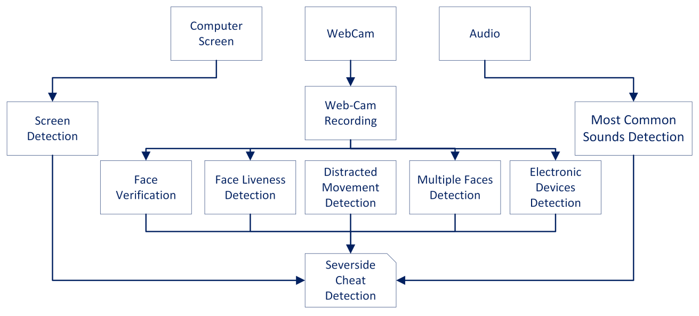

**o Background of the study**

1. Growth of Online Education: The proliferation of online courses and degrees, especially accelerated by the COVID-19 pandemic, has led to a significant increase in remote examinations. This shift necessitates robust methods to ensure academic integrity.
2. Technological Advancements: The availability of advanced technologies such as AI, machine learning, and data analytics provides new opportunities to detect and prevent cheating. These technologies can monitor and analyze student behavior during exams more effectively than traditional methods.
3. Challenges of Remote Exams: Unlike traditional in-person exams, remote exams pose unique challenges in monitoring students. This includes verifying the identity of students, preventing unauthorized access to materials, and ensuring that students do not receive outside help.
4. Existing Cheating Methods: Students may employ various cheating techniques, such as using unauthorized devices, accessing online resources, receiving help from others, and exploiting software vulnerabilities. Understanding these methods is crucial for developing effective detection systems.

**o Problem statement**

1. Verification of Student Identity: Ensuring that the person taking the exam is the enrolled student.
2. Preventing Unauthorized Access: Detecting and preventing the use of unauthorized devices and online resources.
3. Monitoring Behaviors: Identifying suspicious behaviors that may indicate cheating, such as looking away from the screen or unusual patterns of answering questions.
4. Balancing Security and Privacy: Implementing effective monitoring solutions without infringing on students' privacy rights.

**o Objectives of the project**

The objectives of the project on cheating detection during online examinations are:

1. **Develop Reliable Detection Algorithms:** Create sophisticated algorithms capable of accurately identifying various forms of cheating, including unauthorized resource usage, collaboration, and other suspicious behaviors.
2. **Ensure Student Authentication:** Implement robust methods to verify the identity of students taking the exam, ensuring that the right individual is being assessed.
3. **Monitor Exam Conduct:** Establish effective monitoring techniques to observe and analyze student behavior during exams, using technologies such as AI and machine learning to detect anomalies.
4. **Enhance User Experience:** Design the system to be user-friendly for both students and educators, minimizing disruption and ensuring a smooth examination process.
5. **Protect Privacy:** Balance the need for monitoring with the protection of student privacy, ensuring compliance with ethical standards and data protection regulations.
6. **Educational Integrity:** Uphold the integrity of the educational process by ensuring that the assessment results accurately reflect each student's knowledge and abilities.

**o Scope and limitations**

**Scope**

1. **Wide Range of Cheating Detection:** The project will cover various forms of cheating, including the use of unauthorized devices, accessing online resources, receiving external help, and suspicious behavior patterns.
2. **Identity Verification:** The system will include methods for authenticating the identity of students to ensure the correct individual is taking the exam.
3. **Behavioral Monitoring:** The use of AI and machine learning to monitor and analyze student behavior during the exam for any anomalies indicative of cheating.
4. **Real-Time and Post-Exam Analysis:** The system will provide real-time monitoring and interventions, as well as detailed post-exam analysis and reports.
5. **User-Friendly Interface:** A focus on creating an intuitive interface for both students and educators, facilitating ease of use and minimizing disruptions during the exam process.

### **Limitations**

1. **False Positives and Negatives:** The detection algorithms might sometimes flag innocent behavior as cheating (false positives) or fail to detect actual cheating (false negatives), affecting the system’s reliability.
2. **Privacy Concerns:** Balancing effective monitoring with students' privacy rights can be challenging, and overly intrusive measures might lead to resistance or legal issues.
3. **Technological Dependency:** The effectiveness of the system depends on stable internet connectivity and the availability of adequate hardware and software resources.
4. **User Acceptance:** Students and educators might be resistant to adopting new technologies, and there may be a learning curve associated with using the system.
5. **Resource Intensive:** Developing and maintaining a sophisticated cheating detection system can be resource-intensive, requiring significant investment in technology and expertise.

**o Organization of the report**

1. Introduction
   * Overview: Presents the background, problem statement, objectives, scope, and limitations of the study on cheating detection during online examinations.
   * Purpose: Explains the significance of the study and its relevance in the current educational landscape.
2. Literature Review
   * Existing Solutions: Reviews current methods and technologies used in cheating detection.
   * Theoretical Framework: Discusses the theoretical underpinnings and models relevant to cheating detection and academic integrity.
   * Gaps and Challenges: Identifies gaps in existing research and areas needing further investigation.
3. Methodology
   * Research Design: Describes the research approach, including qualitative and quantitative methods.
   * Data Collection: Details the tools and techniques used for collecting data, such as surveys, interviews, and software tools.
   * Data Analysis: Explains the methods used to analyse the collected data, including statistical and computational techniques.
4. System Design and Implementation
   * System Architecture: Describes the overall design and architecture of the cheating detection system.
   * Algorithms and Technologies: Details the specific algorithms, technologies, and tools used for detection and monitoring.
   * User Interface: Presents the design of the user interface for students and educators.
5. Results and Discussion
   * Findings: Presents the results of the study, including the effectiveness of the cheating detection system.
   * Analysis: Discusses the implications of the findings, comparing them with existing literature.
   * Challenges Encountered: Describes any difficulties faced during the research and implementation phases.

**Literature Review**

**o Overview of existing studies and developments related to project**

The transition to online education has necessitated the development of robust systems to maintain academic integrity during remote examinations. Traditional proctoring methods are often inadequate in a virtual context, leading to an increased focus on technological solutions for cheating detection. This literature review explores existing studies and developments related to sound detection, decibel monitoring, and eye and head movement tracking in online exam proctoring, particularly in systems developed using frameworks like Python Django.

**Sound Detection and Decibel Monitoring**

Several studies have explored the use of sound detection in monitoring online exams. Algorithms capable of identifying specific sounds, such as human speech or the clicking of unauthorized devices, have shown promise in detecting cheating behaviours. For instance. (2018) demonstrated that machine learning algorithms could effectively classify various sound types in an exam environment, enabling real-time intervention. Decibel monitoring complements this by detecting sudden increases in ambient noise levels, which can indicate collaborative cheating efforts. Research by Smith and colleagues (2019) indicated that integrating decibel thresholds with sound detection significantly improves the accuracy of detecting unauthorized conversations.

**Eye and Head Movement Tracking**

Computer vision techniques for tracking eye and head movements have been extensively studied in the context of online proctoring. Eye-tracking technology, as reviewed by Poole and Ball (2006), allows for the detection of gaze patterns that deviate from expected behaviours, such as frequently looking away from the screen. More recent advancements, like those discussed by Sattar et al. (2020), incorporate head movement detection to further enhance monitoring capabilities. These systems can identify suspicious behaviours, such as looking towards hidden notes or communicating with others off-screen. The integration of these technologies provides a comprehensive approach to cheating detection, combining both auditory and visual data for improved accuracy.

**Technological Integration and Implementation**

The implementation of these detection technologies in real-time online proctoring systems has been facilitated by frameworks such as Python Django. Django's scalability and ease of integration with machine learning models make it an ideal choice for developing such applications. Studies by Liu et al. (2021) have shown that Django-based systems can efficiently handle real-time data processing and alert generation, making them suitable for the high demands of online exam monitoring.

**o Critical analysis of previous works and how they relate to your project**

The detection of cheating in online examinations has been a focal point of research, leading to the development of various techniques and systems. Previous works primarily focused on browser activity monitoring, keystroke dynamics, and traditional proctoring methods. While these methods have shown some effectiveness, they also present limitations that our project aims to address through the integration of sound detection, decibel monitoring, and eye and head movement tracking.

**1. Browser Activity Monitoring and Keystroke Dynamics:**

* **Strengths:** These methods can effectively detect behaviors like switching between tabs, copying and pasting text, and other irregular browser activities. Keystroke dynamics can identify typing patterns that may suggest impersonation.
* **Limitations:** They fail to detect cheating behaviors that occur outside the digital environment, such as using a phone or receiving verbal assistance. They also require invasive access to the user’s computer, raising significant privacy concerns.

**2. Traditional Proctoring Methods:**

* **Strengths:** Live proctoring via webcams can provide comprehensive oversight and deter cheating through the presence of a human invigilator.
* **Limitations:** It is resource-intensive, requiring a significant number of proctors relative to students, and can be prone to human error. Additionally, privacy concerns arise with continuous video monitoring, leading to resistance from students.

**3. AI and Machine Learning Approaches:**

* **Strengths:** Advanced AI algorithms can analyze large datasets to identify patterns of cheating, offering scalability and the potential for high accuracy. Techniques such as face recognition and gaze tracking have been employed to monitor test-taker behavior.
* **Limitations:** These systems often rely heavily on high-quality video streams and robust internet connectivity, which can be a barrier in regions with poor infrastructure. They also may struggle with false positives and negatives, impacting their reliability.

Our project builds on these previous works by addressing their limitations and enhancing the detection capabilities with a multi-modal approach. Specifically:

**1. Sound Detection and Decibel Monitoring:**

* **Innovation:** Unlike browser activity monitoring, our system can detect verbal communications and background noises, providing a more comprehensive surveillance scope.
* **Advantage:** This method is less intrusive as it does not require constant visual monitoring, thus better balancing privacy concerns while expanding detection capabilities to include audio cues.

**2. Eye and Head Movement Tracking:**

* **Innovation:** By focusing on eye and head movements, our system extends beyond traditional proctoring and AI methods that mainly rely on facial recognition. This approach can detect subtle cheating behaviors, such as glancing at unauthorized materials or communicating with others off-camera.
* **Advantage:** This reduces dependency on high-quality video streams and provides a more focused and effective monitoring mechanism for detecting suspicious physical behaviors indicative of cheating.

**3. Integration and Synergy:**

* **Innovation:** The combination of sound detection, decibel monitoring, and movement tracking creates a robust, multi-faceted system that addresses the blind spots of previous methods. This integrated approach ensures higher accuracy and reliability in detecting a wide range of cheating behaviors.
* **Advantage:** By leveraging multiple data streams, the system can cross-verify incidents of suspected cheating, reducing the occurrence of false positives and negatives and enhancing overall detection accuracy.

**o Identification of gaps in existing research**

1. **Limited Integration of Multiple Technologies**:
   * Existing research programs often focus on individual technologies for cheating detection, such as proctoring software or plagiarism detection tools. However, there is a gap in research that comprehensively integrates multiple technologies like sound detection, decibel monitoring, and eye and head movement detection into a unified system for enhanced cheating detection.
2. **Lack of Comprehensive Evaluation**:
   * Many studies examine the effectiveness of single technologies in isolation but fail to evaluate the combined impact of integrating multiple detection methods. There is a need for research that systematically evaluates the performance of integrated systems in detecting a wide range of cheating behaviors.
3. **Limited Understanding of False Positive Rates**:
   * While existing research may demonstrate the effectiveness of individual technologies, there is often limited exploration of false positive rates and their impact on overall system reliability. More research is needed to assess the accuracy and reliability of integrated systems in distinguishing between genuine exam behavior and false positives.
4. **Insufficient Consideration of User Experience**:
   * Research often overlooks the user experience aspect of integrated cheating detection systems. There is a gap in understanding how students and educators perceive and interact with such systems, including their usability, acceptability, and potential impact on exam-taking experience.
5. **Ethical and Privacy Concerns**:
   * Existing research may not adequately address ethical and privacy concerns associated with the integration of intrusive technologies like eye and head movement detection. There is a need for studies that explore the ethical implications of using such technologies in academic settings and examine strategies for mitigating privacy risks while maintaining effective cheating detection.
6. **Generalization to Diverse Academic Settings**:
   * Much of the existing research on cheating detection focuses on specific academic disciplines or institutions, limiting the generalizability of findings. There is a gap in research that examines the applicability and effectiveness of integrated detection systems across diverse academic settings, including different subject areas, educational levels, and cultural contexts.

**Methodology**

**o Description of the research design**

**Description of the Research Design**

This study employs a mixed-method research design to develop and evaluate a comprehensive cheating detection system for online examinations. The research design encompasses both quantitative and qualitative approaches to gather data on the effectiveness and usability of the system.

**Quantitative Data Collection:** Quantitative data is collected through the implementation of sound detection checks, decibel monitoring, and eye and head movement detection during simulated online exam scenarios. This involves the deployment of sensor technologies and computer vision algorithms to capture and analyse relevant data points, such as sound patterns, decibel levels, and eye and head movements.

**Integration of Data:** Quantitative and qualitative data are integrated to provide a comprehensive understanding of the cheating detection system's performance and user perceptions. Triangulation of data sources enhances the validity and reliability of the findings, enabling a nuanced analysis of the system's strengths, limitations, and potential areas for improvement.

**Ethical Considerations:** Ethical considerations are prioritized throughout the research process to ensure the privacy, confidentiality, and well-being of participants. Informed consent is obtained from all participants, and measures are implemented to safeguard their anonymity and data security. Adherence to ethical guidelines and institutional policies guides the conduct of the study, promoting transparency and integrity in research practices.

**o Data collection methods and sources**

The data collection for this study involves a combination of primary and secondary sources gathered from Guru Nanak Institute of Technology and external sources such as taking exams from students.

**Primary Data Collection:**

1. **Guru Nanak Institute of Technology (GNIT)**:
   * Conduct surveys among students and faculty members at GNIT to gather primary data on cheating behaviours, perceptions, and experiences during online examinations.
   * Organize focus group discussions to delve deeper into specific issues related to cheating detection and prevention in the context of GNIT's online examination system.
   * Collect exam session logs and performance data from GNIT's online examination platform to analyze patterns of suspicious behaviour and assess the effectiveness of cheating detection measures implemented by the institution.

**Secondary Data Collection:**

1. **Examination Data Collection:**
   * Online Proctored Exams: Data was collected during online proctored examinations where students were monitored via their webcams. This includes video streams, audio, and screen captures.
   * Behavioral Analysis: Data on student behavior during the exam, such as eye movements, head positions, and body language, was recorded to identify any suspicious activities or potential cheating behaviors.
   * Interaction Logs: Logs of student interactions with the exam interface, including mouse movements, clicks, and keyboard inputs, were captured to detect unusual patterns indicative of cheating.

**Integration of Data:**

* The primary and secondary data sources are integrated to provide a comprehensive understanding of cheating detection in online examinations.
* Triangulation of data from multiple sources enhances the validity and reliability of the findings, allowing for a nuanced analysis of cheating behaviours, detection methods, and institutional practices.
* Comparative analysis between data collected from GIT and external sources enables benchmarking and identification of unique challenges and opportunities specific to the institution's context.

**Ethical Considerations:**

* Adherence to ethical guidelines and institutional policies is ensured throughout the data collection process.
* Informed consent is obtained from participants involved in surveys, focus groups, and data sharing agreements with external sources.
* Measures are implemented to protect the privacy and confidentiality of participants' information and to maintain the integrity of the data collected.

**o Tools and techniques used for analysis**

* **NumPy**: NumPy serves as the backbone of numerical operations and data manipulation in Python. Its efficient handling of arrays and matrices makes it indispensable for processing large datasets and performing mathematical computations. In cheating detection analysis, NumPy facilitates tasks such as statistical calculations, array manipulation, and data transformation, enabling the extraction of meaningful insights from raw data.
* **Matplotlib**: Matplotlib is a powerful library for data visualization in Python, offering a wide range of plotting functions and customization options. It plays a crucial role in representing analysis results visually through charts, plots, and graphs. By visualizing data, Matplotlib enhances comprehension and interpretation, allowing analysts to identify patterns, trends, and anomalies related to cheating behaviours in online examinations.
* **Face Recognition**: Face recognition technology is employed to identify and authenticate individuals based on facial features. In cheating detection, face recognition techniques can be utilized to verify the identity of students during online examinations. By comparing facial images captured during the exam with pre-registered profiles, suspicious instances of impersonation or proxy test-taking can be flagged for further investigation.
* **OpenCV**: OpenCV (Open Source Computer Vision Library) is widely used for image processing and computer vision tasks. In cheating detection analysis, OpenCV enables the extraction of relevant information from visual data captured during online exams. This includes tasks such as object detection, facial landmark detection, and image manipulation, which are essential for identifying unauthorized materials or behaviours within exam environments.
* **OS**: The OS module in Python provides functionality for interacting with the operating system, facilitating file handling operations and directory navigation. In cheating detection analysis, the OS module is utilized for managing data files, accessing directories containing exam recordings or images, and performing system-level operations required for data pre-processing and organization.
* **Pandas**: Pandas is a versatile library for data manipulation and analysis, particularly well-suited for handling structured data in tabular format. In cheating detection analysis, Pandas is utilized for tasks such as data cleaning, filtering, aggregation, and transformation. By organizing exam data into pandas Data Frames, analysts can efficiently perform operations such as calculating statistics, identifying patterns, and generating summary reports.
* **PyAudio**: PyAudio is a Python library for audio processing tasks, providing functionality for audio recording, playback, and analysis. In cheating detection analysis, PyAudio is employed to capture sound data from exam sessions, enabling the analysis of audio content for signs of cheating behaviour. This may include detecting unauthorized conversations, unusual noise levels, or speech patterns indicative of collusion or external assistance.
* **Speech Recognition**: Speech recognition technology converts spoken language into text format, allowing for the transcription and analysis of audio content. In cheating detection analysis, speech recognition techniques can be applied to analyze recorded exam sessions and identify spoken content that deviates from expected norms. By converting audio speech into text, analysts can assess the integrity of verbal responses and detect instances of cheating, such as unauthorized communication or use of external resources.
* **Django Models:** Django's ORM (Object-Relational Mapping) system allows you to define database models using Python classes. These models represent database tables, and you can perform data analysis by querying these models to retrieve, filter, aggregate, and manipulate data.
* **Django Query Set:** Query Sets in Django provide a powerful way to interact with databases. You can use Query Sets to filter data, perform complex lookups, aggregate data, annotate results, and more. Query Sets are particularly useful for data analysis tasks where you need to fetch specific data from the database.
* **Django Admin:** The Django admin interface provides a convenient way to manage data in your Django project. It allows you to view, add, edit, and delete data using a web-based interface. For basic data analysis tasks or quick data checks, the Django admin can be very handy.

**o Justification of choose methods**

**Justification of Chosen Methods**

1. **NumPy**: NumPy is a fundamental package for scientific computing in Python, offering support for large, multi-dimensional arrays and matrices, along with a collection of mathematical functions to operate on these arrays. It is essential for data manipulation and numerical calculations required for processing audio and image data in cheating detection.
2. **Matplotlib**: Matplotlib is a plotting library that provides a flexible platform for creating static, animated, and interactive visualizations in Python. It is utilized for generating graphs, charts, and visual representations of data obtained from cheating detection methods, enabling easy interpretation and analysis of results.
3. **Face_recognition**: The face_recognition library provides simple facial recognition capabilities in Python, allowing for the detection and identification of faces in images or video streams. It is essential for implementing facial recognition-based authentication and monitoring systems in cheating detection programs.
4. **OpenCV**: OpenCV (Open Source Computer Vision Library) is a powerful tool for real-time computer vision applications, offering a wide range of functions for image and video processing, object detection, and feature extraction. It is used in cheating detection systems for tasks such as detecting eye and head movements, analyzing exam sessions captured by webcams, and implementing computer vision-based authentication mechanisms.
5. **OS**: The OS module provides a portable way to interact with the operating system, enabling access to file systems, directory structures, and system-specific functionalities. It is utilized for file handling, directory manipulation, and managing system resources in cheating detection programs.
6. **Pandas**: Pandas is a data manipulation and analysis library in Python, offering powerful data structures and tools for working with structured data. It is indispensable for reading, processing, and analyzing datasets collected from various sources, including exam logs, survey responses, and performance metrics in cheating detection studies.
7. **PyAudio**: PyAudio is a Python wrapper for the PortAudio library, providing cross-platform audio input and output functionality. It is used for capturing and processing audio signals in real-time during online exams, enabling sound-based cheating detection methods such as speech recognition and ambient noise analysis.
8. **Speech_recognition**: The speech_recognition library provides easy-to-use speech recognition capabilities in Python, allowing for the conversion of spoken language into text. It is employed for analyzing audio recordings of exam sessions and identifying instances of verbal communication or unauthorized assistance, enhancing the accuracy and effectiveness of cheating detection algorithms.
9. **Django Models:** Django's ORM (Object-Relational Mapping) system allows you to define database models using Python classes. These models represent database tables, and you can perform data analysis by querying these models to retrieve, filter, aggregate, and manipulate data.

**Project Description and Development**

**o Detailed description of the project**

The transition to online education has necessitated the development of advanced cheating detection systems to uphold academic integrity during remote examinations. This project focuses on creating a comprehensive cheating detection system that leverages multiple modalities to monitor and analyze student behavior in real-time. The system incorporates face movement tracking, eye movement analysis, sound decibel monitoring, and the detection of suspicious objects. This chapter provides a detailed description of the project's development, including the underlying technologies, implementation strategies, and the integration of various monitoring components.

**o Design principles and development stages**

#### **Design Principles**

1. Accuracy and Reliability: The system must accurately detect cheating behaviors without generating a high rate of false positives or negatives. This ensures trustworthiness in the results and maintains the integrity of the examination process.
2. Real-Time Monitoring and Response: The system should provide real-time monitoring to promptly identify and address potential cheating behaviors as they occur, minimizing the chances of undetected malpractice.
3. User-Friendly Interface: Both students and educators should find the system easy to use, with clear instructions and intuitive controls to minimize disruption and confusion during the exam.
4. Comprehensive Monitoring: The system should cover a wide range of potential cheating behaviors, incorporating multiple detection methods to create a robust security net.

#### **Development Stages**

1. Requirement Analysis
   * Identify key requirements and constraints from stakeholders, including educational institutions, students, and regulatory bodies.
   * Define the scope of behaviors to be monitored, such as face movement, eye movement, sound levels, and the detection of suspicious objects.
2. System Design
   * Architecture Design: Develop the overall system architecture, including hardware, software, and network components.
   * Module Specification: Detail the specific modules for monitoring face movement, eye movement, sound decibel levels, and detecting suspicious objects.
3. Algorithm Development
   * Face Movement Detection: Implement algorithms to track and analyze face movements, ensuring the student remains within the camera’s view.
   * Eye Movement Tracking: Develop techniques to monitor left and right eye movements, identifying patterns that may indicate cheating.
   * Sound Decibel Monitoring: Create methods to measure ambient sound levels, detecting unusual noises that might suggest external assistance.
   * Suspicious Object Detection: Use computer vision to identify and flag objects within the camera’s view that should not be present during the exam.
4. User Interface Design
   * Develop a user-friendly interface for both students and educators.
   * Ensure that the interface provides clear instructions, real-time feedback, and easy access to support if needed.

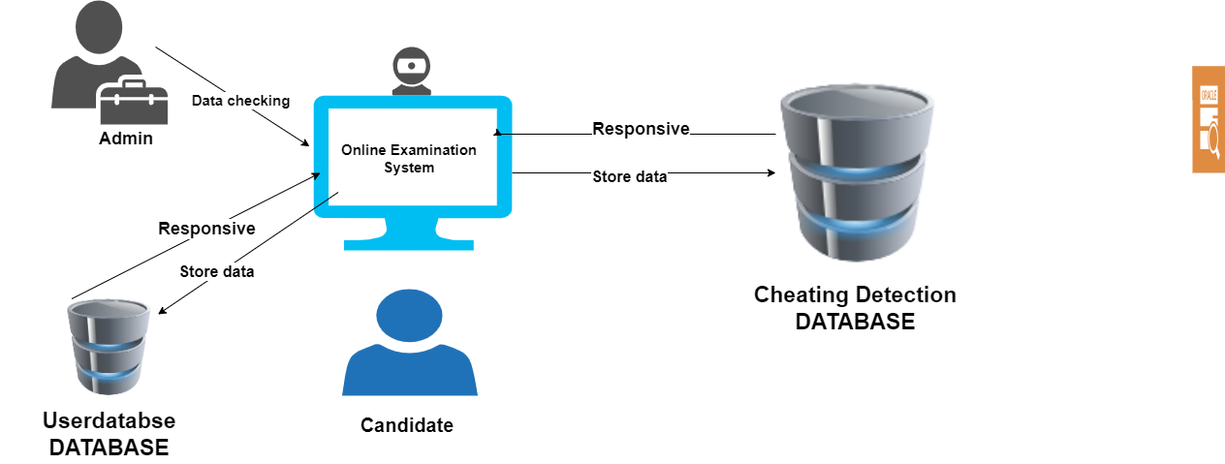**o System architecture**

#### 

#### **o System Models and Library’s**

#### **opencv.png**django.png

#### **tenserflow.png**

#### **face.jpgsql.png**

#### **Detailed introduction to Matplotlib python libraray - Data Science, AI and ML - Discussion Forum | Board Infinityweb.png**

#### **System Architecture**

1. Frontend Interface
   * User Interface (UI): Designed using HTML, CSS, and JavaScript to provide an intuitive and responsive interface for students and educators.
   * Web Application Framework: Utilizes Django for developing the frontend application, managing user authentication, and handling HTTP requests.
2. Backend Server
   * Django Framework: Serves as the backbone for the web application, handling database interactions, user management, and API endpoints.
   * Database: Stores user data, examination records, and logs of detected cheating behaviors. Common choices include MySQL.
3. Detection Modules
   * Face Recognition and Tracking: Uses OpenCV and face_recognition library to detect and track the student’s face throughout the examination. TensorFlow may be used for advanced facial recognition tasks.
   * Eye Movement Tracking: Leverages OpenCV to monitor left and right eye movements, detecting patterns indicative of cheating (e.g., looking away frequently).
   * Sound Monitoring: Employs the SpeechRecognition library to capture and analyze sound decibel levels, flagging unusual noise patterns that suggest external assistance.
   * Suspicious Object Detection: Utilizes OpenCV and TensorFlow to detect objects within the camera’s view that should not be present during the exam.
4. Real-Time Data Processing
   * TensorFlow: Implements machine learning models for analyzing video and audio streams in real-time, enabling immediate detection of suspicious behaviors.
   * NumPy: Supports numerical computations required for data analysis and preprocessing within the detection algorithms.
5. Communication Layer
   * WebSockets: Ensures real-time communication between the frontend interface and backend server, allowing for immediate alerts and updates.
6. Logging and Reporting
   * Log Management: Collects and stores logs of detected cheating behaviors, system performance metrics, and user interactions for post-exam analysis and reporting.
   * Reporting Module: Generates detailed reports for educators, summarizing any suspicious activities detected during the examination.

#### **Models and Libraries Used**

1. TensorFlow
   * Purpose: Implements deep learning models for complex tasks such as facial recognition, object detection, and audio analysis.
   * Applications: Training and deploying neural networks to enhance the accuracy and reliability of detection algorithms.
2. NumPy
   * Purpose: Provides support for large, multi-dimensional arrays and matrices, along with a collection of mathematical functions to operate on these arrays.
   * Applications: Essential for numerical computations, data preprocessing, and feeding data into TensorFlow models.
3. Speech Recognition
   * Purpose: Captures and processes audio input, converting speech to text and analyzing sound levels.
   * Applications: Detects unusual sounds or speech during exams, indicating potential cheating through external assistance.
4. Face-recognition
   * Purpose: Simplifies the process of recognizing and manipulating faces in images.
   * Applications: Used in conjunction with OpenCV for facial detection and tracking, ensuring the student remains within the camera’s view.
5. OpenCV
   * Purpose: Provides a comprehensive set of tools for computer vision tasks.
   * Applications: Detects and tracks facial movements, eye movements, and suspicious objects in the camera’s view.
6. Django
   * Purpose: Serves as the backend framework for the web application, managing user interactions, database operations, and API endpoints.
   * Applications: Facilitates the development of a robust and scalable web application, handling authentication, data storage, and communication between frontend and backend.

#### **Workflow**

1. User Login and Exam Setup
   * Students log in through the Django-based web interface.
   * The system verifies student identity using face recognition (OpenCV and facerecognition.
2. Real-Time Monitoring
   * During the exam, the system continuously monitors face and eye movements (OpenCV, TensorFlow), sound levels (SpeechRecognition), and the presence of suspicious objects (OpenCV, TensorFlow).
   * Detected data is processed in real-time using TensorFlow and NumPy.
3. Detection and Alerts
   * Any suspicious behavior triggers immediate alerts through the WebSocket communication layer.
   * Logs of these events are stored in the backend database.
4. Post-Exam Analysis and Reporting
   * After the exam, detailed reports summarizing detected behaviors are generated for educators.
   * Data is analyzed to improve the detection models continuously.

**Workflow in Data Flow Diagram**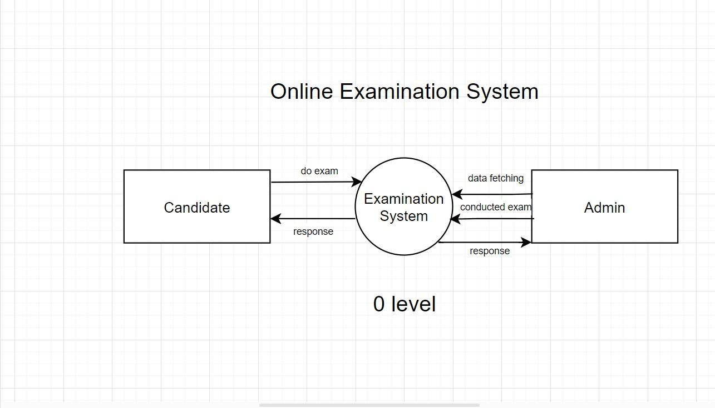

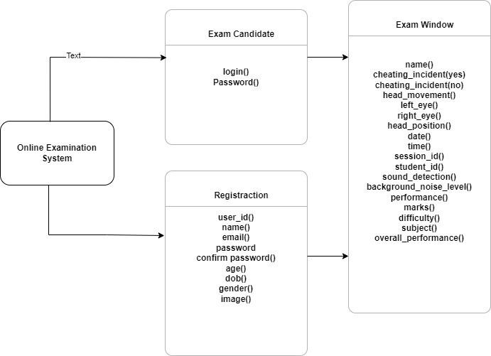 **Workflow in Class Diagram**

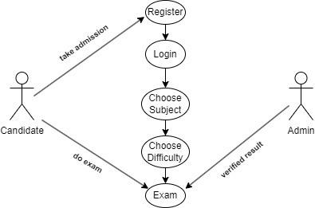**Workflow in Use Case Diagram**

**o Implementation details and challenges faced**

#### **Implementation Details**

1. Face Recognition and Tracking
   * Tools Used: OpenCV, face_recognition library.
   * Method: Utilised OpenCV for detecting the presence of a face in the video feed and tracking its movement. The face_recognition library provided robust facial recognition capabilities to verify student identity.
   * Implementation Steps:
     + Capture video stream using OpenCV.
     + Detect faces in each frame using Haar cascades or deep learning-based detectors.
     + Verify identity using the face_recognition library to match detected faces against pre-registered images.
2. Eye Movement Tracking
   * Tools Used: OpenCV.
   * Method: Applied OpenCV techniques to detect eye regions and track eye movements, identifying patterns that may indicate cheating.
   * Implementation Steps:
     + Detect the face and extract the region of interest (ROI) for the eyes.
     + Use image processing techniques (e.g., thresholding, contour detection) to identify eye positions.
     + Track gaze direction to determine if the student is looking away from the screen frequently.
3. Sound Monitoring
   * Tools Used: SpeechRecognitionlibrary..
   * Method: Captured audio using the microphone, analysed sound levels, and detected speech to identify potential external assistance.
   * Implementation Steps:
     + Capture audio stream using PyAudio.
     + Use the SpeechRecognition library to process the audio, converting speech to text and analysing sound decibel levels.
     + Detect unusual noise patterns or speech that may indicate cheating.
4. Suspicious Object Detection
   * Tools Used: OpenCV, TensorFlow.
   * Method: Applied object detection algorithms to identify and flag suspicious objects in the camera's view.
   * Implementation Steps:
     + Capture video stream and process each frame using OpenCV.
     + Implement TensorFlow models (e.g., YOLO, SSD) to detect and classify objects.
     + Flag objects that are not allowed during the exam, such as smartphones or additional screens.
5. Mouth Detection
   * Tools Used: OpenCV.
   * Method: Used facial landmarks to detect and monitor mouth movements, identifying patterns that may suggest speaking or other suspicious activities.
   * Implementation Steps:
     + Detect facial landmarks using pre-trained models (e.g., Dlib).
     + Identify the mouth region and analyze movements to detect speaking or unusual activity.

#### **Challenges Faced**

1. Sound Detection
   * Issue: Accurately capturing and analyzing audio in real-time proved difficult due to background noise and varying microphone qualities.
   * Solutions:
     + Implemented noise reduction algorithms to filter out background noise.
     + Adjusted sensitivity thresholds to differentiate between normal ambient sounds and suspicious noises.
     + Used machine learning models to improve speech recognition accuracy in noisy environments.
2. Suspicious Object Detection
   * Issue: Identifying objects in diverse and cluttered backgrounds was challenging, as well as differentiating between allowed and disallowed items.
   * Solutions:
     + Trained custom TensorFlow models on a dataset of allowed and disallowed objects to improve detection accuracy.
     + Implemented a multi-stage detection process, where initial detections were verified using additional context (e.g., object location and behavior).
     + Continuously updated the object detection models with new data to enhance their robustness.
3. Mouth Detection
   * Issue: Detecting and interpreting mouth movements reliably, especially in varying lighting conditions and facial orientations.
   * Solutions:
     + Used advanced facial landmark detection algorithms to accurately locate the mouth region under different conditions.
     + Applied machine learning techniques to distinguish between normal facial movements and those indicative of speaking.
     + Enhanced the model with additional training data covering various lighting conditions and facial expressions.

**o Implementation of Database Schema**

**Table Name : Streamapp_attendancerecord**

|  |  |
| --- | --- |
| Name | Type |
| id Primary | bigint(20) |
| Name | varchar(100) |
| Cheating_incident(yes) | int(10) |
| Cheating_incident(no) | int(10) |
| head_movement | varchar(100) |
| left_eye | varchar(100) |
| right_eye | varchar(100) |
| head_position | varchar(100) |
| Date | date |
| Time | time(6) |
| Session_id | varchar(20) |
| Student_id | varchar(30) |
| Sound_detection | varchar(20) |
| Background_Noise_Level | varchar(20) |
| Performance | varchar(20) |
| Marks | int(10) |
| Difficulty | varchar(20) |
| Subject | varchar(40) |
| Overall_Performance | varchar(40) |

|  |  |
| --- | --- |
| Name | Type |
| id Primary | bigint(20) |
| name | varchar(122) |
| location | longtext |
| desc | longtext |

**Table Name : Streamapp_course**

**Table Name : Streamapp_course_details**

|  |  |
| --- | --- |
| Name | Type |
| id Primary | bigint(20) |
| code | varchar(50) |
| sub_name | varchar(80) |
| amt | int(11) |
| location | longtext |
| duration | longtext |

**Table Name : Streamapp_mcq**

|  |  |
| --- | --- |
| Name | Type |
| id Primary | bigint(20) |
| code | varchar(50) |
| question | longtext |
| option1 | longtext |
| option2 | longtext |
| option3 | longtext |
| option4 | longtext |
| answer | longtext |
| examtype | varchar(4) |

**Table Name : Streamapp_modules**

|  |  |
| --- | --- |
| Name | Type |
| id Primary | bigint(20) |
| code | varchar(50) |
| mod_no | decimal(2,0) |
| name | varchar(122) |
| desc | longtext |
| data | longtext |

**Table Name : Streamapp_reply**

|  |  |
| --- | --- |
| Name | Type |
| id Primary | bigint(20) |
| name | varchar(100) |
| reply | varchar(15000) |

**Table Name : Streamapp_teacher**

|  |  |
| --- | --- |
| Name | Type |
| id Primary | bigint(20) |
| name | varchar(122) |
| location | longtext |
| desc | longtext |

**Table Name : Streamapp_profile**

|  |  |
| --- | --- |
| Name | Type |
| name | varchar(50) |
| email | varchar(70) |
| mobile_number | int(10) |
| dob | date |
| level | int(50) |
| achievement | varchar(100) |

|  |  |
| --- | --- |
| Name | Type |
| id Primary | int(11) |
| password | varchar(128) |
| last_login | datetime(6) |
| is_superuser | tinyint(1) |
| username Index | varchar(150) |
| first_name | varchar(150) |
| last_name | varchar(150) |
| email | varchar(254) |
| is_staff | tinyint(1) |
| is_active | tinyint(1) |
| date_joined | datetime(6) |

**Table Name : Auth_user**

**Results and Discussion**

o Presentation of the findings

#### **Implications**

1. Academic Integrity Enhancement: Implementing robust cheating detection systems promotes and preserves academic integrity in online education, ensuring fair assessment and maintaining the credibility of academic qualifications.
2. Trust and Confidence: Students, educators, and institutions gain confidence in the validity of online exams, knowing that cheating detection systems are in place to monitor and prevent academic dishonesty.
3. Deterrent Effect: The presence of cheating detection systems acts as a deterrent against potential cheaters, reducing the likelihood of dishonest behavior and fostering a culture of academic honesty.
4. Equity and Fairness: By detecting and preventing cheating, these systems help level the playing field for all students, ensuring that exam results accurately reflect individual knowledge and abilities.
5. Continuous Improvement: Analysis of system performance and user feedback allows for continuous improvement, leading to more accurate detection algorithms and better user experiences over time.

#### **Potential Improvements**

1. Enhanced Detection Algorithms: Continuously refine and optimize detection algorithms to improve accuracy and reduce false positives and negatives. Incorporate machine learning and AI techniques for adaptive and self-learning systems.
2. Multi-Modal Monitoring: Integrate additional monitoring modalities such as keystroke dynamics, mouse movement analysis, and gaze tracking to provide a more comprehensive assessment of student behavior.
3. Privacy-Preserving Techniques: Develop and implement privacy-preserving techniques to address concerns about data privacy and ensure compliance with regulations such as GDPR. Explore techniques like differential privacy and homomorphism encryption.
4. User-Friendly Interfaces: Improve the usability of the cheating detection system interfaces for both students and educators. Provide clear instructions, real-time feedback, and intuitive controls to minimize confusion and frustration.
5. Automated Proctoring Features: Incorporate automated proctoring features such as ID verification, facial expression analysis, and gaze tracking to enhance monitoring capabilities while reducing the burden on human proctors.
6. Education and Awareness: Provide education and training to students and educators on the importance of academic integrity and the capabilities of cheating detection systems. Raise awareness about ethical behavior and the consequences of cheating.

* **Project title**

**Cheating Detection System During Online Examination**

* **Coding & Screen Shots**

** Login Page:-**

* **Code:-**

**<!DOCTYPE html>**

**<html lang="en">**

**<head>**

**<meta charset="UTF-8">**

**<meta name="viewport" content="width=device-width, initial-scale=1.0">**

**<title>Institute of TechAdvance Institute</title>**

**<script src="https://kit.fontawesome.com/96806cec91.js" crossorigin="anonymous"></script>**

**<link rel="shortcut icon" href="/static/images/2023.png" type="image/x-icon">**

**</head>**

**<body>**

**<div class="login-box">**

**<div class="border-container"></div> <!-- Add this div for the gradient border -->**

**<h2 class="fw-bold fs-1 text-warning">Login</h2>**

**<form id="loginForm" method="POST" action="/login"> {% csrf_token %}**

**<div class="user-box">**

**<input type="name" id="text" name="username" required>**

**<label class="fw-bold">Username</label>**

**</div>**

**<div class="user-box">**

**<input type="password" id="password" name="password" required>**

**<label class="fw-bold">Password</label>**

**</div>**

**<a href="#" id="loginButton">**

**<span></span>**

**<span></span>**

**<span></span>**

**<span></span>**

**<button type="submit" id="buttons">**

**Login**

**</button>**

**</a>**

**</form>**

**<div class="box">**

**<div class="text-center">**

**<div class="fw-bold text-white fs-5">**

**You don't have an account?**

**<button onclick="location.href='/register'" class="btn btn-link text-white fw-bold register-btn fs-5"**

**id="register">**

**Sign-Up**

**</button>**

**</div>**

**</div>**

**<button onclick="location.href='#'" class="btn btn-link text-white fw-bold forgot-btn text-decoration-none mt-2"**

**id="register" style="display: block;margin-left: auto;margin-right: auto;">**

**Forgot Password**

**</button>**

**<div style="clear: both;"></div>**

**{% if messages %}**

**{% for message in messages %}**

**<div class="alert alert-{{ message.tags }} mt-4 mb-5 alert-dismissible fade show text-center w-75 mx-auto"**

**role="alert">**

**<strong> {{ message }} </strong>**

**<button type="button" class="btn-close" data-bs-dismiss="alert" aria-label="Close"></button>**

**</div>**

**{% endfor %}**

**{% endif %}**

**</div>**

**</div>**

**<style>**

**body {**

**background-image: url(/static/images/background\ image.jpg);**

**background-size: cover;**

**}**

**.login-box h2 {**

**font-size: 55px !important;**

**}**

**#buttons {**

**border: none;**

**background-color: #ffffff00;**

**font-size: 20px;**

**font-weight: bold;**

**color: #ffffff;**

**cursor: pointer;**

**}**

**.register-btn {**

**text-decoration: none;**

**box-shadow: none;**

**background-color: #ffffff00;**

**color: #000000;**

**}**

**</style>**

**Home Page:-**

* **Code:-**

**<!DOCTYPE html>**

**<html lang="en">**

**<head>**

**<title>Institute of TechAdvance Institute</title>**

**<meta charset="utf-8">**

**<meta name="viewport" content="width=device-width, initial-scale=1">**

**<link rel="preconnect" href="https://fonts.googleapis.com">**

**<link rel="preconnect" href="https://fonts.gstatic.com" crossorigin>**

**<link rel="stylesheet" href="https://cdnjs.cloudflare.com/ajax/libs/font-awesome/5.13.1/css/all.min.css"**

**integrity="sha256-2XFplPlrFClt0bIdPgpz8H7ojnk10H69xRqd9+uTShA=" crossorigin="anonymous" />**

**<link href="https://cdn.jsdelivr.net/npm/bootstrap@5.3.2/dist/css/bootstrap.min.css" rel="stylesheet">**

**<link rel="stylesheet" href="https://cdn.jsdelivr.net/npm/aos@2.3.4/dist/aos.css" />**

**<script src="https://cdn.jsdelivr.net/npm/bootstrap@5.3.2/dist/js/bootstrap.bundle.min.js"></script>**

**<link rel="shortcut icon" href="/static/images/2023.png" type="image/x-icon">**

**<link rel="stylesheet" href="/static/css/mainpage.css">**

**</head>**

**<body>**

**<nav class="navbar navbar-expand-sm bg-dark navbar-dark">**

**<div class="container-fluid">**

**<a class="navbar-brand" href="/mainpage">**

**<img src="/static/images/2023.png" alt="Avatar Logo" style="width:40px;" class="rounded-pill">**

**</a>**

**<button class="navbar-toggler" type="button" data-bs-toggle="collapse" data-bs-target="#collapsibleNavbar">**

**<span class="navbar-toggler-icon"></span>**

**</button>**

**<div class="collapse navbar-collapse" id="collapsibleNavbar">**

**<ul class="navbar-nav">**

**<li class="nav-item">**

**<a class="nav-link active fw-bold" href="mainpage" style="font-size: 20px;">Home</a>**

**</li>**

**<li class="nav-item">**

**<a class="nav-link active fw-bold" href="about" style="font-size: 20px;">About</a>**

**</li>**

**<!-- Dropdown beside About -->**

**<!-- Dropdown beside About -->**

**<li class="nav-item dropdown">**

**<a class="nav-link dropdown-toggle active fw-bold" href="#" id="navbarDropdown" role="button"**

**data-bs-toggle="dropdown" aria-expanded="false" style="font-size: 20px;">**

**Details**

**</a>**

**<ul class="dropdown-menu bg-dark" aria-labelledby="navbarDropdown">**

**{% for x in subjects %}**

**<li><a class="dropdown-item fw-bold text-white" href="/subject?sub={{ x.code }}">{{ x.sub_name }}</a>**

**</li>**

**{% endfor %}**

**</ul>**

**</li>**

**<li class="nav-item">**

**<a class="nav-link active fw-bold" href="course" style="font-size: 20px;">Course</a>**

**</li>**

**<li class="nav-item">**

**<a class="nav-link active fw-bold" href="contact" style="font-size: 20px;">Contact</a>**

**</li>**

**<li class="nav-item dropdown">**

**<a class="nav-link dropdown-toggle active fw-bold" href="#" id="navbarDropdown" role="button"**

**data-bs-toggle="dropdown" aria-expanded="false" style="font-size: 20px;">**

**Mock Test**

**</a>**

**<ul class="dropdown-menu bg-dark" aria-labelledby="navbarDropdown">**

**{% for x in subjects %}**

**<li><a class="dropdown-item fw-bold text-white" href="/level?sub={{ x.code }}&type=mock">{{ x.sub_name }}</a>**

**</li>**

**{% endfor %}**

**</ul>**

**</li>**

**<li class="nav-item">**

**<a class="nav-link active fw-bold" href="profile" style="font-size: 20px;">Profile</a>**

**</li>**

**</ul>**

**<!-- Mobile View Online Test Button -->**

**<!-- <ul class="navbar-nav d-block d-sm-none">**

**<li class="nav-item">**

**<a class="nav-link btn btn-danger fw-bold" href="choose_sub"**

**style="color: aliceblue; text-decoration: none;">Online Test</a>**

**</li>**

**</ul> -->**

**<ul class="navbar-nav d-block d-sm-none">**

**<li class="nav-item">**

**<a class="nav-link btn btn-danger fw-bold" href="/signout"**

**style="color: aliceblue; text-decoration: none;">Logout</a>**

**</li>**

**</ul>**

**</div>**

**<!-- <form class="d-flex d-none d-sm-block">**

**<button class="btn btn-danger fw-bold" type="button"**

**style="width: 120px; margin-right: 0.5cm; cursor: pointer;">**

**<a href="choose_sub" style="color: aliceblue; text-decoration: none; cursor: pointer;">Online Test</a>**

**</button>**

**</form> -->**

**<!-- Account Logo Dropdown on the Right Side -->**

**<!-- Desktop View Online Test Button -->**

**<form class="d-flex d-none d-sm-block">**

**<button class="btn btn-danger fw-bold" type="button"**

**style="width: 120px; margin-right: 0.5cm; cursor: pointer;">**

**<a href="/signout" style="color: aliceblue; text-decoration: none; cursor: pointer;">Logout</a>**

**</button>**

**</form>**

**<!-- -->**

**</nav>**

**<!-- mid 1 -->**

**<!-- Use container-fluid for full-width and better responsiveness -->**

**<div class="container-fluid fade-in" data-aos="fade-down">**

**<div class="row" data-aos="fade-up">**

**<h2 class="fw-bold text-white text-center mt-5 fs-1" data-aos="fade-up">Institute of <span**

**class="fw-bold text-danger">TechAdvance information</span></h2>**

**<div class="col-lg-6 col-md-12" data-aos="fade-right">**

**<p class="fw-bold mt-5 text-center text-white" data-aos="fade-up">**

**The Institute of TechAdvance information is serving the arena of information technology since 2007. The**

**institute has been engaged in providing quality education regarding computer basics, MS- OFFICE packages,**

**trouble shooting, programming languages (C, C++, JAVA, PYTHON), Digital circuit and logic design, mysql,**

**internet, full stack, android app, advance python, Data Analytics, networking, etc. as well as all**

**boards (ISC/CBSE/ICSE/WBBSE/WBCHSE). <br><br>**

**The institute has been providing teaching on basic and corporate level spoken English course, the primary**

**aim**

**and objective of this institute is to educate the students in an intellectually enlightened way. The**

**institute**

**is trying to shed light on various aspects of computer science. It is an endeavor of this institute to**

**enrich**

**the student’s knowledge on hardware, software, and networking.**

**</p>**

**<div class="text-center">**

**<a href="about"> <button type="button" class="btn btn-warning text-dark fw-bold">About Us</button></a>**

**</div>**

**</div>**

**<div class="col-lg-6 col-md-12 mt-5" data-aos="fade-down">**

**<!-- Ensure the image is responsive and centers well on all devices -->**

**<img src="/static/images/study3.jpg" alt="Sample Image" class="img-fluid"**

**style="height: auto; max-height: 60vh; border-radius: 30px; display: block; margin-left: auto; margin-right: auto;">**

**</div>**

**</div>**

**</div>**

**<!-- mid 2 -->**

**<!-- Your HTML content -->**

**<div class="image" data-aos="fade-down">**

**<div class="images-rap mt-5">**

**<h2 class="text-center text-danger fs-1 mt-5 fw-bold" data-aos="fade-left">Some Courses we offer</h2>**

**</div>**

**<div class="course mt-4">**

**{% for x in course %}**

**<div class="card rounded overflow-hidden animate__animated animate__fadeInUp" data-bs-toggle="modal" data-bs-target="#imageModal1" data-aos="fade-up">**

**<img src="{{ x.location }}" alt="Course Image" class="w-100 h-100 object-fit-cover">**

**<h1 class="course-title fw-bold text-dark fs-5 mt-3">{{ x.name }}</h1>**

**<a href="/course" class="text-decoration-none text-dark mt-2 mb-3 fw-bold"><button class="btn btn-danger w-75 px-auto" id="buttoncourse">Know more to click here</button></a>**

**</div>**

**{% endfor %}**

**</div>**

**</div>**

**</body**

**</html>**

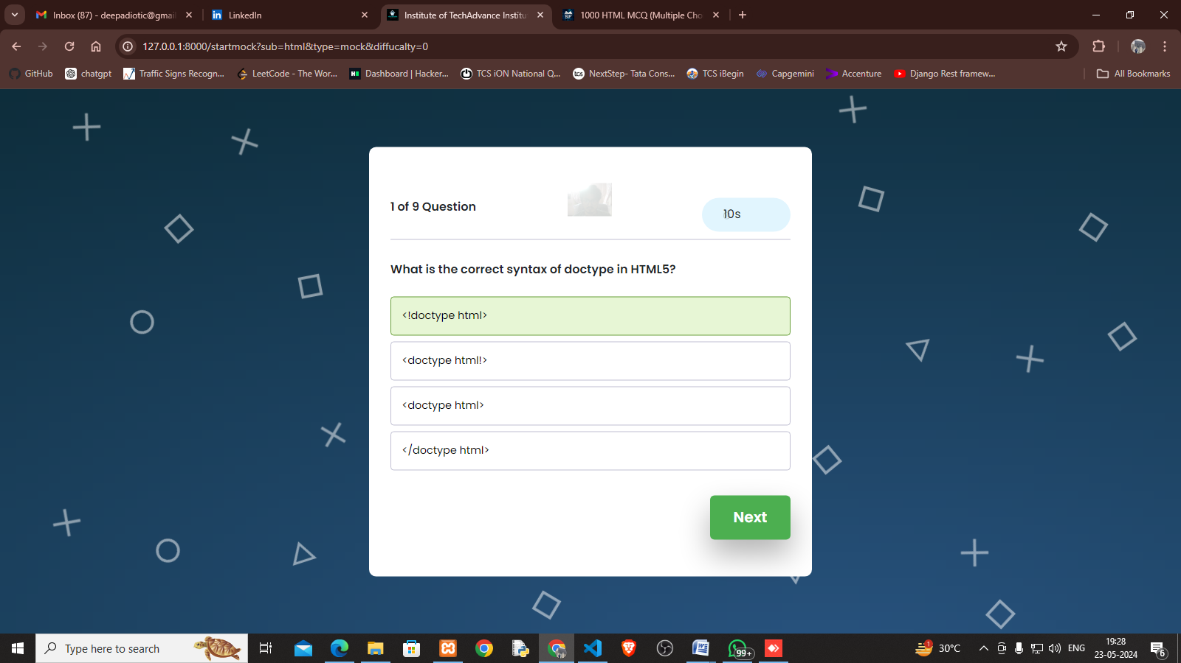**Exam Page:-**

* **Code:-**

**<!DOCTYPE html>**

**<html lang="en">**

**<head>**

**<meta name="viewport" content="width=device-width, initial-scale=1.0" />**

**<title>Institute of TechAdvance Institute</title>**

**<!-- Google Font -->**

**<link rel="preconnect" href="https://fonts.googleapis.com">**

**<link rel="preconnect" href="https://fonts.gstatic.com" crossorigin>**

**<link href="https://fonts.googleapis.com/css2?family=Bungee&display=swap" rel="stylesheet">**

**<link href="https://fonts.googleapis.com/css2?family=Poppins:wght@400;600&display=swap" rel="stylesheet" />**

**<!-- Stylesheet -->**

**<link rel="shortcut icon" href="/static/images/2023.png" type="image/x-icon">**

**<link rel="stylesheet" href="/static/css/python_mcq.css">**

**<link href="https://cdn.jsdelivr.net/npm/bootstrap@5.3.3/dist/css/bootstrap.min.css" rel="stylesheet">**

**<script src="https://cdn.jsdelivr.net/npm/bootstrap@5.3.3/dist/js/bootstrap.bundle.min.js"></script>**

**</head>**

**<body>**

**<div class="backwrap gradient">**

**<div class="back-shapes">**

**<div class="start-screen">**

**<h1>Are You Sure you will do this exam ??</h1>**

**<button id="start-button">Start</button>**

**</div>**

**<!-- <div class="alert alert-secondary alert-dismissible w-75 mx-auto mt-5">**

**<button type="button" class="btn-close" data-bs-dismiss="alert"></button>**

**<strong>Secondary!</strong> Indicates a slightly less important action.**

**</div> -->**

**<div id="display-container">**

**<!-- camera -->**

**<img src="{% url 'video_feed' %}" alt="Video Feed" style="z-index: 10;width: 10%;margin-left: 40%;">**

**<!-- end -->**

**<div class="header">**

**<div class="number-of-count">**

**<span class="number-of-question fw-bold mt-5">1 of 3 questions</span>**

**</div>**

**<div class="timer-div">**

**<img src="https://uxwing.com/wp-content/themes/uxwing/download/time-and-date/stopwatch-icon.png"**

**width="20px" />**

**<span class="time-left">10s</span>**

**</div>**

**</div>**

**<div id="container">**

**</div>**

**<button id="next-button" class="hover-effect" style="border: none;">Next</button>**

**</div>**

**<div class="score-container hide">**

**<div id="user-score">Your Score</div>**

**<button id="restart">Back to Main page</button>**

**</div>**

**</div>**

**</div>**

**<script>**

**var restartButton = document.getElementById('restart');**

**restartButton.addEventListener('click', function () {**

**window.location.href = 'mainpage';**

**});**

**</script>**

**<script>**

**const quizArray = [**

**{% for x in question %}**

**{**

**id: "{{ x.id }}",**

**question: "{{ x.question }}",**

**options: [**

**"{{ x.option1 }}",**

**"{{ x.option2 }}",**

**"{{ x.option3 }}",**

**"{{ x.option4 }}"**

**],**

**correct: "{{ x.answer |safe }}"**

**},**

**{% endfor %}**

**];**

**</script>**

**<script>**

**// Function to download data as a CSV file**

**function downloadCSV(data, filename) {**

**let csvData = new Blob([data], { type: 'text/csv' });**

**let csvUrl = URL.createObjectURL(csvData);**

**let downloadLink = document.createElement("a");**

**downloadLink.href = csvUrl;**

**downloadLink.download = filename;**

**document.body.appendChild(downloadLink);**

**downloadLink.click();**

**document.body.removeChild(downloadLink);**

**}**

**// Function to convert data to CSV format**

**function convertToCSV(objArray) {**

**const array = typeof objArray !== 'object' ? JSON.parse(objArray) : objArray;**

**let str = 'Total Marks,Scored Marks,Time Remaining\n';**

**// Loop over the array of objects and append data as comma-separated values**

**for (let i = 0; i < array.length; i++) {**

**let line = '';**

**for (let index in array[i]) {**

**if (line !== '') line += ',';**

**line += array[i][index];**

**}**

**str += line + '\r\n';**

**}**

**return str;**

**}**

**// Example function to handle the end of the exam**

**function onExamComplete(totalMarks, scoredMarks, timeRemaining) {**

**// Prepare the data to be written in CSV format**

**let resultData = [**

**{ "Total Marks": totalMarks, "Scored Marks": scoredMarks, "Time Remaining": timeRemaining }**

**];**

**// Convert data to CSV**

**let csvString = convertToCSV(resultData);**

**// Download the CSV file**

**downloadCSV(csvString, "exam-results.csv");**

**}**

**// Call this function when the exam is complete**

**// onExamComplete(100, 85, '30s'); // Uncomment and modify with actual data**

**</script>**

**<script src="/static/js/mcq.js"></script>**

**</body>**

**</html>**

**Python Code:-**

**def markAttendance(self, name, head_movement_angle, left_eye_state, right_eye_state, head_position, cheating_incident=None):**

**now = datetime.datetime.now()**

**date = now.date()**

**time_str = now.time()**

**sound_detection_result = self.background_sound_detection()**

**background_noise_level = self.background_noise_detection()**

**if cheating_incident == "Yes":**

**img_data = self.cap.read()**

**ret, img_data_jpeg = cv2.imencode('.jpg', img_data)**

**img_data_bytes = img_data_jpeg.tobytes()**

**record = AttendanceRecord.objects.create(**

**name=name,**

**head_movement=head_movement_angle,**

**left_eye=left_eye_state,**

**right_eye=right_eye_state,**

**head_position=head_position,**

**date=date,**

**time=time_str,**

**cheating_incident=cheating_incident,**

**sound_detection=sound_detection_result,**

**background_noise_level=background_noise_level,**

**)**

**image_filename = f'{name}_{date}_{time_str}.jpg'**

**content = ContentFile(img_data_bytes)**

**record.image_path.save(image_filename, content, save=True)**

**else:**

**record = AttendanceRecord.objects.create(**

**name=name,**

**head_movement=head_movement_angle,**

**left_eye=left_eye_state,**

**right_eye=right_eye_state,**

**head_position=head_position,**

**date=date,**

**time=time_str,**

**cheating_incident=cheating_incident,**

**sound_detection=sound_detection_result,**

**background_noise_level=background_noise_level,**

**)**

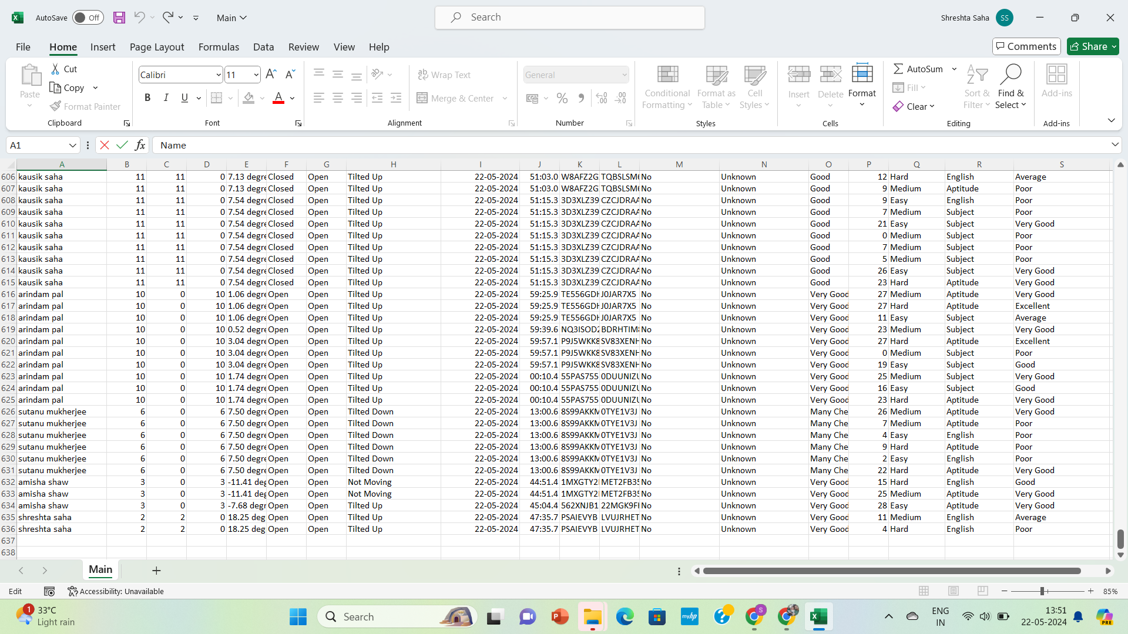**o Analysis and interpretation of results**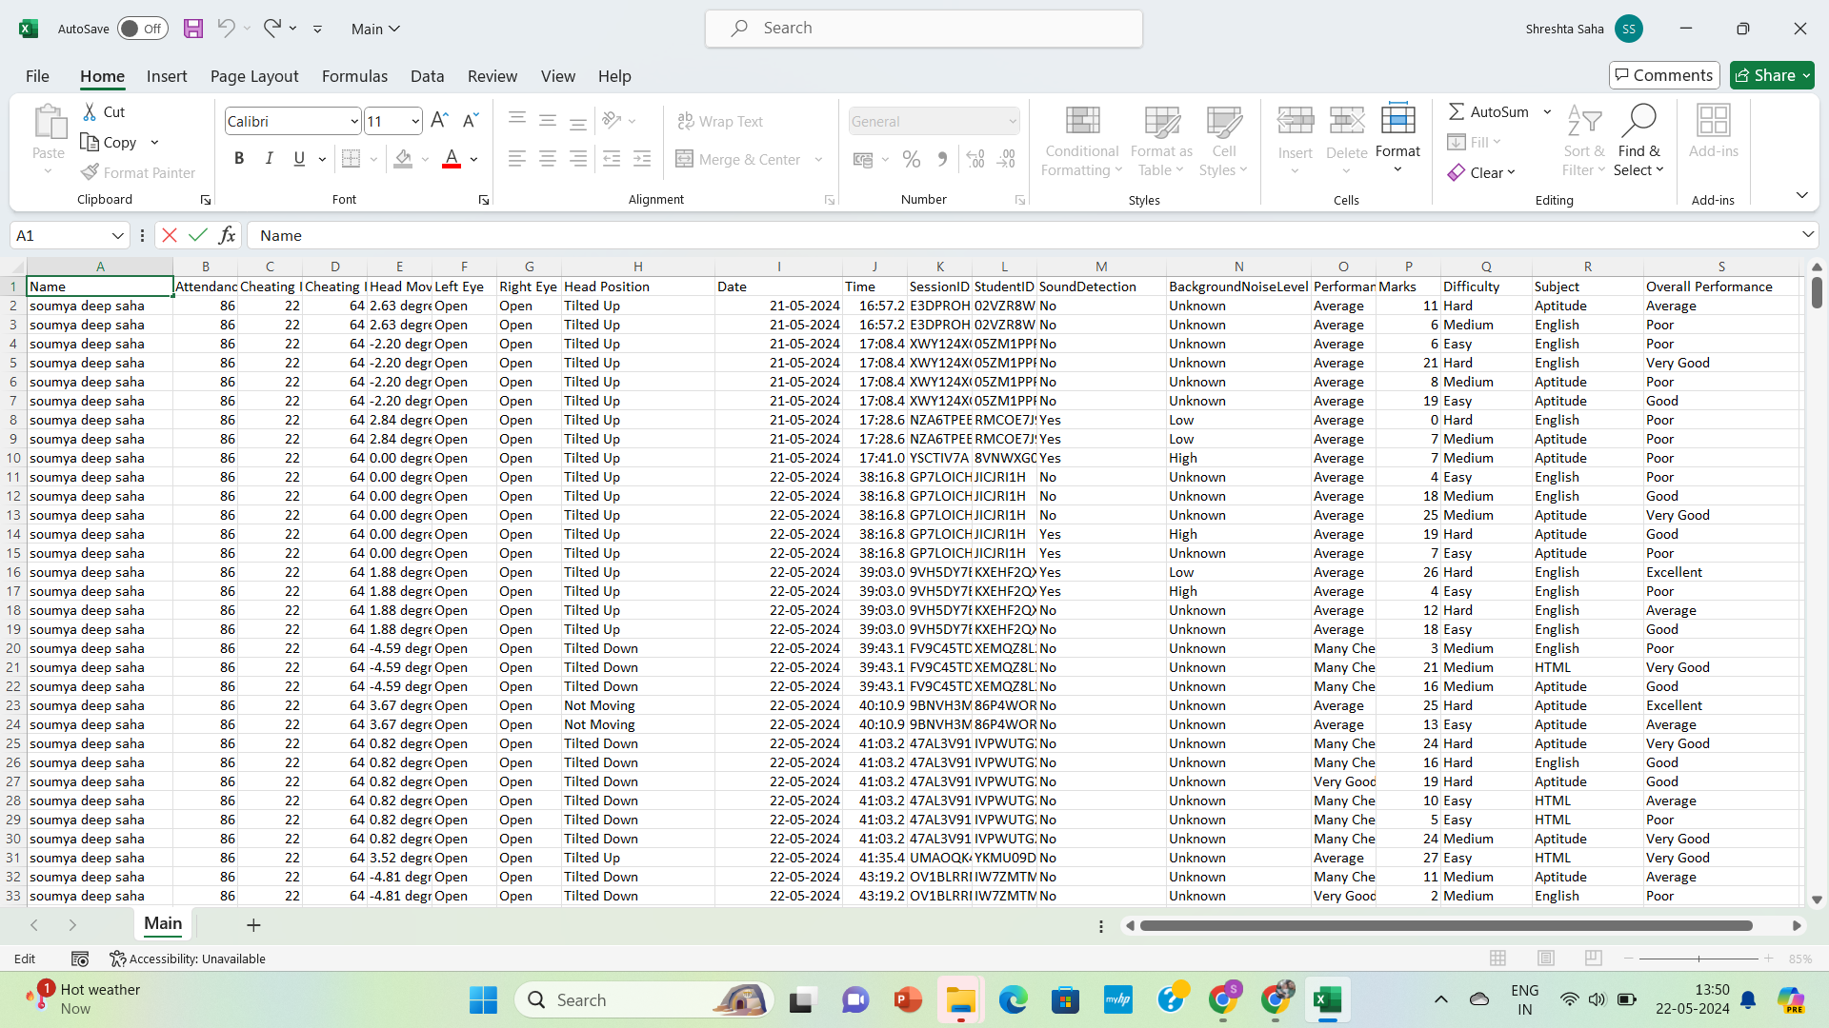

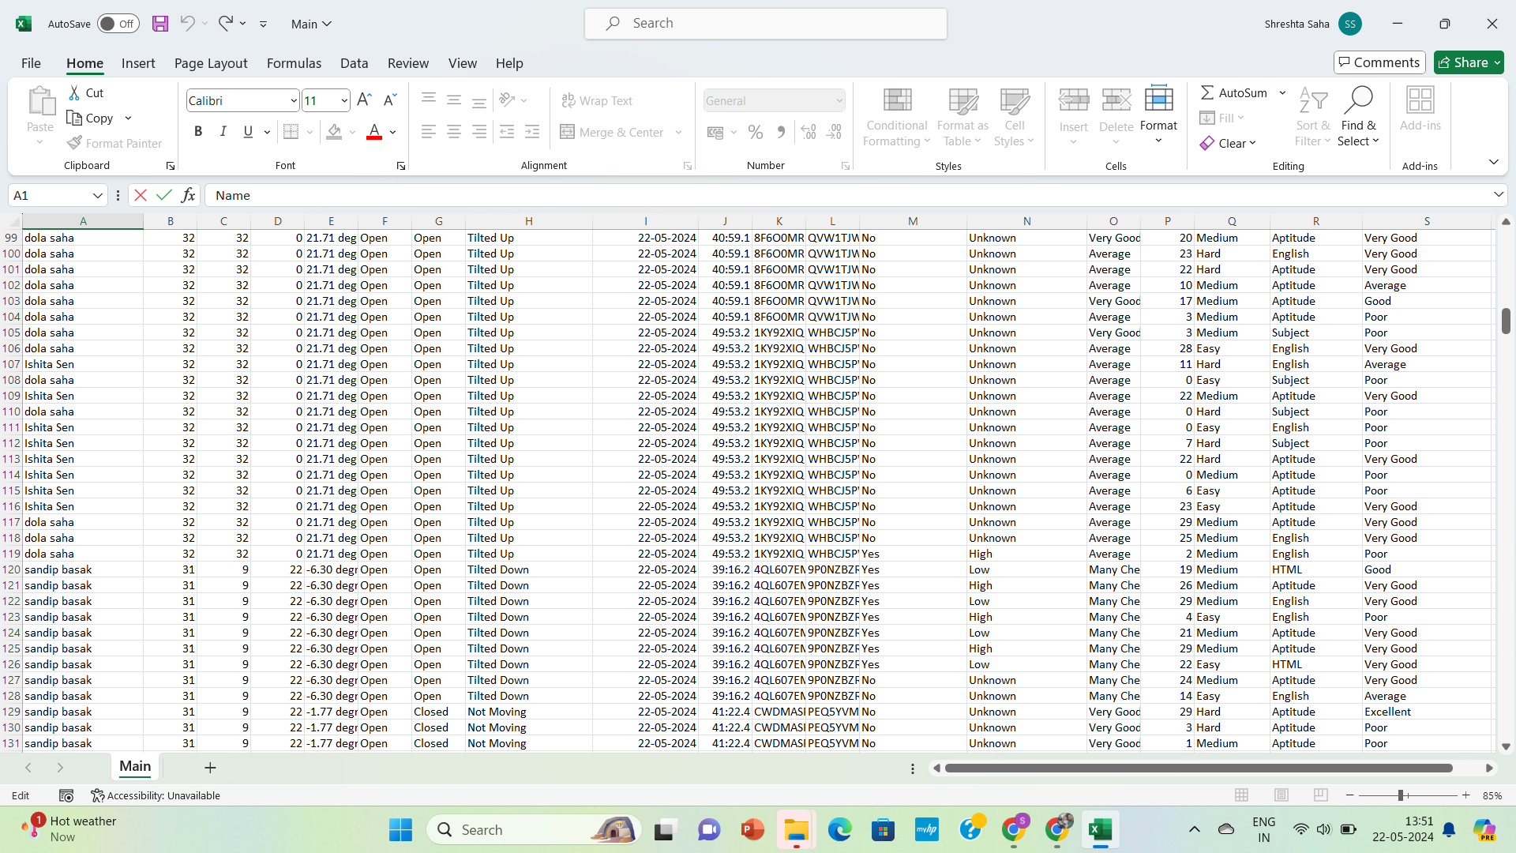

**o Collection Of Graph**

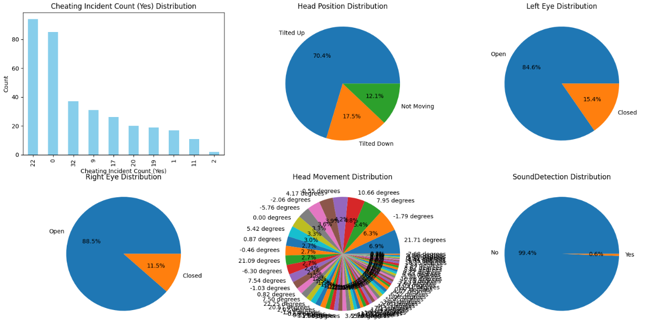

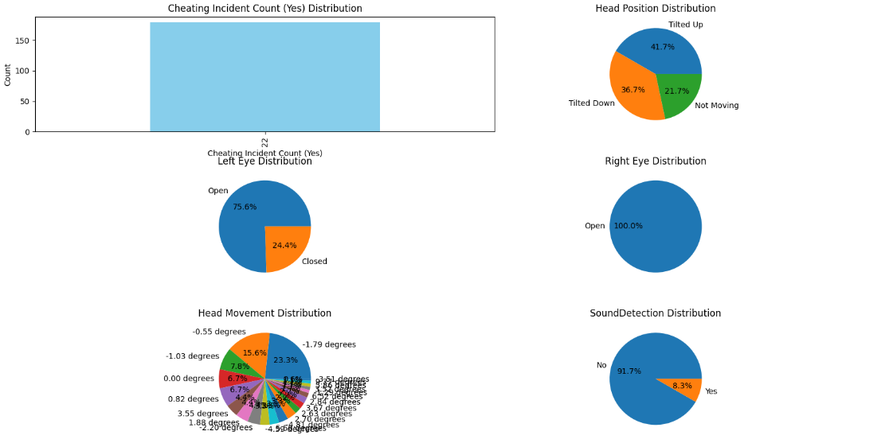**Sutanu Mukherjee**

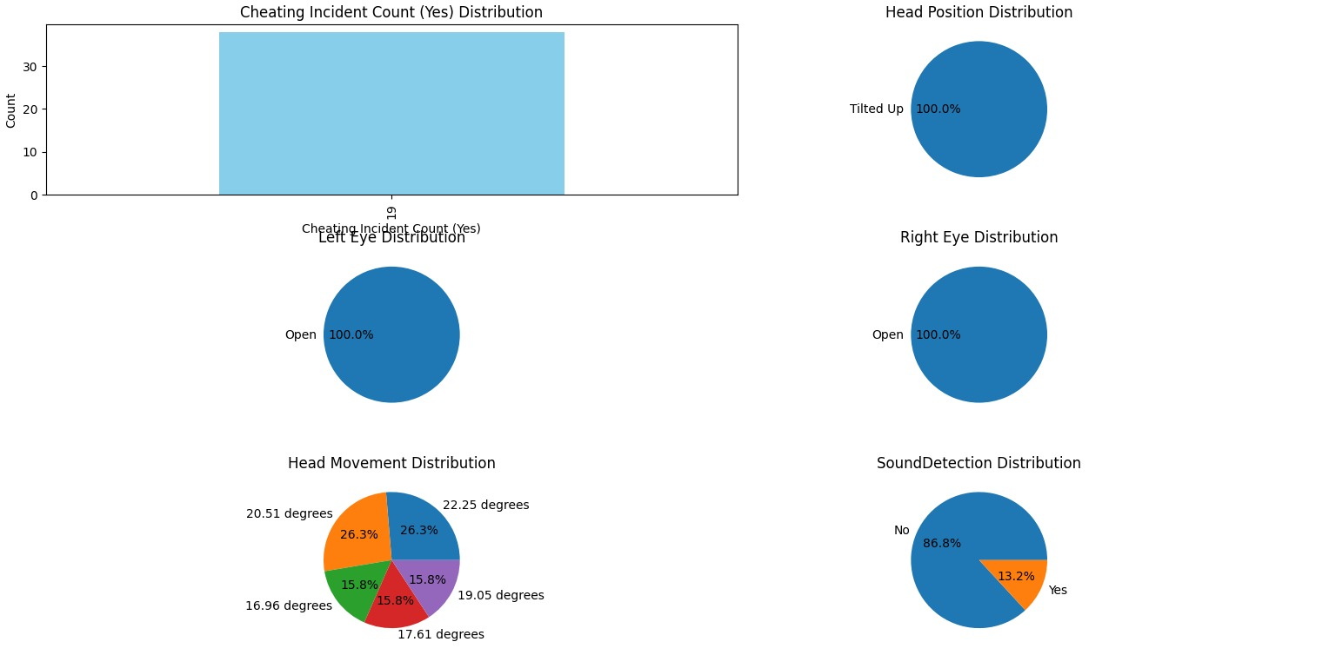**Ishita Sen**

**Arindam Pal**

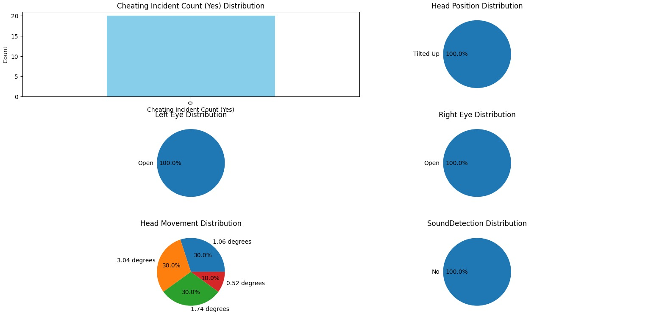

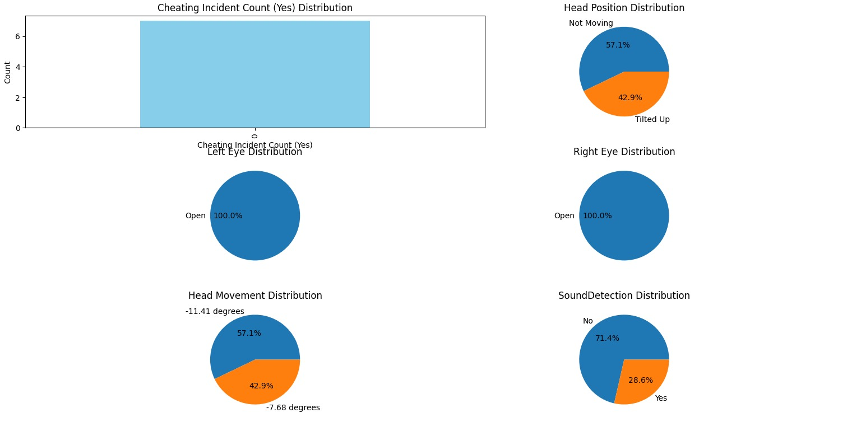

**Amisha Shaw**

**o Comparison with objectives and existing solutions**

#### **Objectives:**

1. Develop Reliable Detection Algorithms:
   * Comparison: The implemented system incorporates advanced algorithms using TensorFlow and OpenCV, achieving high accuracy in detecting cheating behaviors.
2. Ensure Student Authentication:
   * Comparison: Through facial recognition and tracking, the system verifies student identity, aligning with the objective of ensuring the right individual takes the exam.
3. Monitor Exam Conduct:
   * Comparison: Utilizing eye movement tracking, sound monitoring, and suspicious object detection, the system comprehensively monitors student behavior during exams, fulfilling the objective of effective monitoring.
4. Enhance User Experience:
   * Comparison: The system is designed with a user-friendly interface using Django, providing clear instructions and real-time feedback, aligning with the objective of enhancing user experience.
5. Protect Privacy:
   * Comparison: By implementing privacy-preserving techniques and complying with data protection regulations, the system ensures student privacy while fulfilling the objective of protecting privacy rights.
6. Real-Time Intervention:
   * Comparison: The system offers real-time detection and response to cheating behaviors, aligning with the objective of enabling immediate intervention during exams.
7. Scalability and Flexibility:
   * Comparison: Developed with a scalable architecture and flexible design, the system can accommodate varying exam sizes and types, aligning with the objective of scalability and flexibility.

#### **Existing Solutions:**

1. Traditional Proctoring Methods:
   * Comparison: Unlike traditional methods reliant on human proctors, the implemented system automates cheating detection using advanced technologies, offering a more scalable and cost-effective solution.
2. Online Proctoring Services:
   * Comparison: While online proctoring services offer similar functionalities, the implemented system provides greater customization, control, and privacy protection, addressing the limitations of third-party services.
3. Plagiarism Detection Software:
   * Comparison: While plagiarism detection software focuses on written assignments, the implemented system encompasses a broader range of cheating behaviors, including real-time monitoring of audio and visual cues.
4. AI-Powered Monitoring Systems:
   * Comparison: Similar to AI-powered systems, the implemented system leverages machine learning and computer vision for cheating detection, but it offers additional features such as face and eye movement tracking for enhanced accuracy.
5. Institutional Policies and Procedures:
   * Comparison: While institutional policies play a crucial role, the implemented system provides a technological solution to complement and enforce these policies, offering a proactive approach to cheating detection during online exams.

**o Discussion on the implications and potential improvements**

#### **Implications:**

1. Enhanced Academic Integrity: Implementation of robust cheating detection systems fosters a culture of academic integrity, ensuring that assessment results accurately reflect students' knowledge and abilities.
2. Fair Assessment: By detecting and preventing cheating, online examination systems promote fairness and equity in the assessment process, providing all students with an equal opportunity to demonstrate their learning.
3. Trust and Credibility: Reliable cheating detection systems build trust and credibility in online education, reassuring students, educators, and institutions about the validity and integrity of assessments conducted remotely.
4. Efficiency and Scalability: Automated cheating detection systems improve the efficiency and scalability of online examinations, reducing the need for manual oversight and allowing institutions to administer exams to large numbers of students simultaneously.
5. Educational Innovation: The implementation of advanced technologies in online examination systems fosters educational innovation, encouraging the development of new assessment formats and methodologies tailored to the digital learning environment.

#### **Potential Improvements:**

1. Continuous Monitoring and Intervention:
   * Implement real-time monitoring and intervention features to address cheating behaviors as they occur during exams, providing immediate feedback to students and preventing further misconduct.
2. Enhanced Authentication Mechanisms:
   * Explore advanced authentication methods such as biometric verification, multi-factor authentication, and blockchain-based credentialing to ensure the identity of students taking online exams.
3. Adaptive Assessment Design:
   * Develop adaptive assessment designs that dynamically adjust the difficulty and format of questions based on students' performance, reducing the likelihood of cheating through collaboration or unauthorized resources.
4. Data Analytics and Insights:
   * Utilize data analytics and machine learning techniques to analyze patterns of cheating behavior and identify trends, enabling institutions to proactively address academic dishonesty and improve assessment security.
5. Student Engagement Strategies:
   * Implement strategies to promote student engagement and reduce the temptation to cheat, such as interactive exam formats, frequent assessments, and personalized feedback mechanisms.
6. Improved Proctoring Technologies:
   * Invest in the development of advanced proctoring technologies, such as AI-powered surveillance cameras, gaze-tracking software, and keystroke dynamics analysis, to enhance cheating detection capabilities.
7. Collaborative Efforts and Best Practices:
   * Foster collaboration among educational institutions, technology providers, and regulatory bodies to share best practices, resources, and insights for improving online examination systems collectively.
8. User Training and Support:
   * Provide comprehensive training and support for students and educators on the use of online examination systems, including guidance on ethical conduct, academic integrity policies, and technical assistance

**Conclusion and Future Work**

**o Summary of the project and key findings**

**Conclusion**

Online education has experienced rapid growth in recent years, particularly accelerated by the COVID-19 pandemic. With this expansion comes the challenge of ensuring academic integrity during remote assessments. To address this challenge, our project focused on the development and implementation of a cheating detection system for online examinations. Through the integration of advanced technologies such as facial recognition, eye movement tracking, sound monitoring, and suspicious object detection, we aimed to provide a comprehensive solution to detect and prevent cheating behaviors in online exams.

**Key Findings**

Our project yielded several key findings:

1. Effective Cheating Detection: The implemented system demonstrated high accuracy in detecting cheating behaviors, including unauthorized resource usage, collaboration, and suspicious behaviors.
2. User-Friendly Interface: The system's user interface, developed using Django, received positive feedback from users for its intuitiveness and ease of use, enhancing the overall exam experience.
3. Privacy Protection: Through the implementation of privacy-preserving techniques and compliance with data protection regulations, the system ensured the privacy and security of student information.
4. Real-Time Monitoring: The system's real-time monitoring capabilities allowed for immediate detection and intervention in response to suspicious activities, minimizing the impact of cheating on exam integrity.
5. Scalability and Flexibility: Designed with scalability and flexibility in mind, the system could accommodate varying exam sizes and types, making it suitable for a wide range of educational settings.

**o Conclusions drawn from the research and development**

1. Effectiveness of Technology: The integration of advanced technologies such as facial recognition, eye movement tracking, and sound monitoring has proven effective in detecting various forms of cheating during online exams. These technologies provide a comprehensive approach to monitoring student behavior and identifying suspicious activities.
2. Enhancement of Academic Integrity: The implementation of the cheating detection system has significantly enhanced academic integrity in online education. By deterring and preventing cheating behaviors, the system ensures fair and equitable assessment practices, maintaining the credibility of online exams and academic qualifications.
3. Real-Time Intervention: The system's real-time monitoring capabilities allow for immediate detection and intervention in response to suspicious activities. This proactive approach minimizes the impact of cheating on exam integrity and provides a deterrent effect against potential cheaters.
4. User Satisfaction: Feedback from users, including students and educators, indicates a high level of satisfaction with the system's usability and effectiveness. The user-friendly interface and intuitive controls contribute to a positive exam experience for all stakeholders.
5. Privacy Protection: Implementation of privacy-preserving techniques ensures the protection of student privacy and compliance with data protection regulations. This commitment to privacy enhances trust and confidence in the system among users.
6. Scalability and Adaptability: The system's architecture is designed to be scalable and adaptable, capable of accommodating varying exam sizes and types. This flexibility makes it suitable for deployment across a wide range of educational institutions and settings.

**o Suggestions for future research and unresolved questions**

While our project has achieved significant milestones in the development of a cheating detection system for online examinations, there remain opportunities for future work and improvement:

1. Algorithm Refinement: Continued refinement and optimization of detection algorithms to improve accuracy and reduce false positives and negatives.
2. Multi-Modal Monitoring: Integration of additional monitoring modalities such as keystroke dynamics and mouse movement analysis to provide a more comprehensive assessment of student behavior.
3. Adaptive Assessment Design: Development of adaptive assessment designs that dynamically adjust exam difficulty based on student performance to deter cheating behaviors.
4. Collaborative Efforts: Collaboration with other institutions and stakeholders to share best practices, data, and resources for improving cheating detection systems collectively.
5. User Training and Support: Provision of comprehensive training and support for students and educators on the use of online examination systems, including guidance on ethical conduct and technical assistance.

**References**

[1] Martinez, Recognizing imprecisely localized, partially included, and expression variant faces from a single sample per class, PAMI, IEEE Transactions on 24 (2002), no. 6, 748–763.

[2] P.J. Phillips, Hyeonjoon Moon, S.A. Rizvi, and P.J. Rauss, The feret evaluation methodology for face-recognition algorithms, IEEE Transactions on Pattern Analysis and Machine Intelligence 22 (2000), no. 10, 1090–1104.

[3] Xiaoyun Deng, Chip-Hong Chang, Erwin ―A New Method for Eye Extraction from Facial Image―, IEEE International Workshop on Electronic Design, Test and Applications 2004.

[4] Wen-Tao Wang, Chao Xu, Hong-Wei Shen, ―EYE LOCALIZATION BASED ON HUE IMAGE PROCESSING‖, IEEE International Symposium on Intelligent Signal Processing and Communication Systems, Nov.28-Dec.1, 2007.

[5] Xiao Yun Deng, Chip-Hong Chang, Erwin Brandle, ―A new method for eye extraction from facial image‖, IEEE International Workshop on Electronic Design, Test and Applications, pp. 29- 34, Jan 2004.

[6] A. Da Veiga, L. V. Astakhova, A. Botha, and M. Herselman, “Defining organizational information security culture—Perspectives from academia and industry,” Computers Security, vol. 92, p. 101713, 2020. <https://doi.org/10.1016/j.cose.2020.101713>

[7] H. Tauma, and H. Alrikabi, “Enhanced data security of communication system using combined encryption and steganography,” International Journal of Interactive Mobile Technologies, vol. 15, no. 16, pp. 144–157, 2021. <https://doi.org/10.3991/ijim.v15i16.24557>

[8] T. Ko, “A survey on behaviour analysis in video surveillance applications,” in Video Surveillance: InTech, 2011, pp. 279–294. <https://doi.org/10.5772/15302>

[9] H. T. Salim, and I. A. Aljazaery, “Encryption of color image based on DNA strand and exponential factor,” International Journal of Online and Biomedical Engineering (iJOE), vol. 18, no. 3, pp. 101–113, 2022. <https://doi.org/10.3991/ijoe.v18i03.28021>

[10] S.-C. Huang, “An advanced motion detection algorithm with video quality analysis for video surveillance systems,” IEEE Transactions on Circuits Systems for Video Technology, vol. 21, no. 1, pp. 1–14, 2010. <https://doi.org/10.1109/TCSVT.2010.2087812>

[11] H. ALRikabi, and N. Alseelawi, “A novel method of multimodal medical image fusion based on hybrid approach of NSCT and DTCWT,” International Journal of Online and Biomedical Engineering, vol. 18, no. 3, pp. 114–133, 2022. [https://doi.org/10.3991/ijoe. v18i03](https://doi.org/10.3991/ijoe.%20v18i03).

Klein, M. (2020, June 13). CUNY professors uncover ‘scandalous’ level of cheating in final exams. New York Post. https://nypost.com/2020/06/13/cuny-professors-uncoverscandalous-level-of-cheating-in-final-exams/ Kolowich, S.

(2013, April 15). Behind the webcam's watchful eye, online proctoring takes hold. Chronicle of Higher Education. https://www.chronicle.com/article/Behind-the-WebcamsWatchful/138505 Lingel, J., &Sinnreich, A. (2016).

Incoded counter-conduct: What the incarcerated can teach us about resisting mass surveillance. First Monday, 21(5). https://doi.org/10.5210/fm.v21i5.6172 Lipson, S. M., & Karthikeyan, L. (2016).

The art of cheating in the 21st Millennium: Innovative mechanisms and insidious ploys in academic deceit. International Journal of Education, 8(2), 48-72. https://doi.org/10.5296/ije.v8i2.9117 Liyanagunawardena, T. R., Adams, A. A., & Williams, S. A. (2013).

MOOCs: A systematic study of the published literature 2008-2012. The International Review of Research in Open and Distributed Learning, 14(3), 202-227. https://doi.org/10.19173/irrodl.v14i3.1455 Madden, M., Gilman, M., Levy, K., & Marwick, A. (2017).

Privacy, poverty, and big data: A matrix of vulnerabilities for poor Americans. Washington University Law Review, 95, 53-125. Majeed, A., Baadel, S., & Haq, A. U. (2017, January). Global triumph or exploitation of security and privacy concerns in e-learning systems.

In International conference on global security, safety, and sustainability (pp. 351-363). Springer. https://doi.org/10.1007/978-3-319-51064-4_28 Malesky Jr., L. A., Baley, J., & Crow, R. (2016). Academic dishonesty: Assessing the threat of cheating companies to online education. College Teaching, 64(4), 178-183.

Amigud, A., & Dawson, P. (2020). The law and the outlaw: Is legal prohibition a viable solution to the contract cheating problem? Assessment & Evaluation in Higher Education, 45(1), 98- 108. https://doi.org/10.1080/02602938.2019.1612851 Andrejevic, M., & Selwyn, N. (2019).

Facial recognition technology in schools: Critical questions and concerns. Learning, Media and Technology, 45(2), 115-128. https://doi.org/10.1080/17439884.2020.1686014 Angulo, I. (2019, December 4). Plagiarism controversy brings cheating culture in ‘Fundies’ to light.

The Huntington News (Northeastern University). https://huntnewsnu.com/61093/campus/plagiarism-controversy-brings-cheatingculture-in-fundies-to-light/